1. Task9: Enhance the MapReduce program of Task 8 (refer session 19, assignment 3) to use multiple reducers for sorting. The driver should accept three additional values: the minimum units sold, the maximum units sold and number of reducers to use. Use units sold as key and company as value. Write a custom partitioner to divide the keys on the basis of range. Take minimum to be 0 and maximum to be 10. Divide them across 2 reducers.

Here we have a driver, mapper, reducer, partitioner and custom Writable to get the custom key and we need to pass the custom key as the company and the sold units and it is sorted as the units sold

Context.getconfiguration.get() is used to get the values from the command line to be used in the program.

Driver:

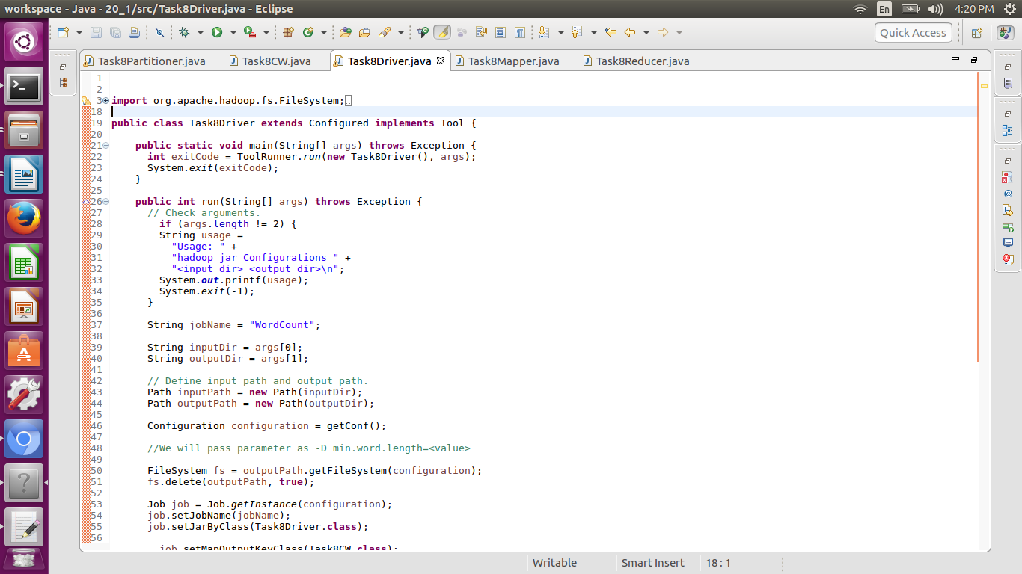

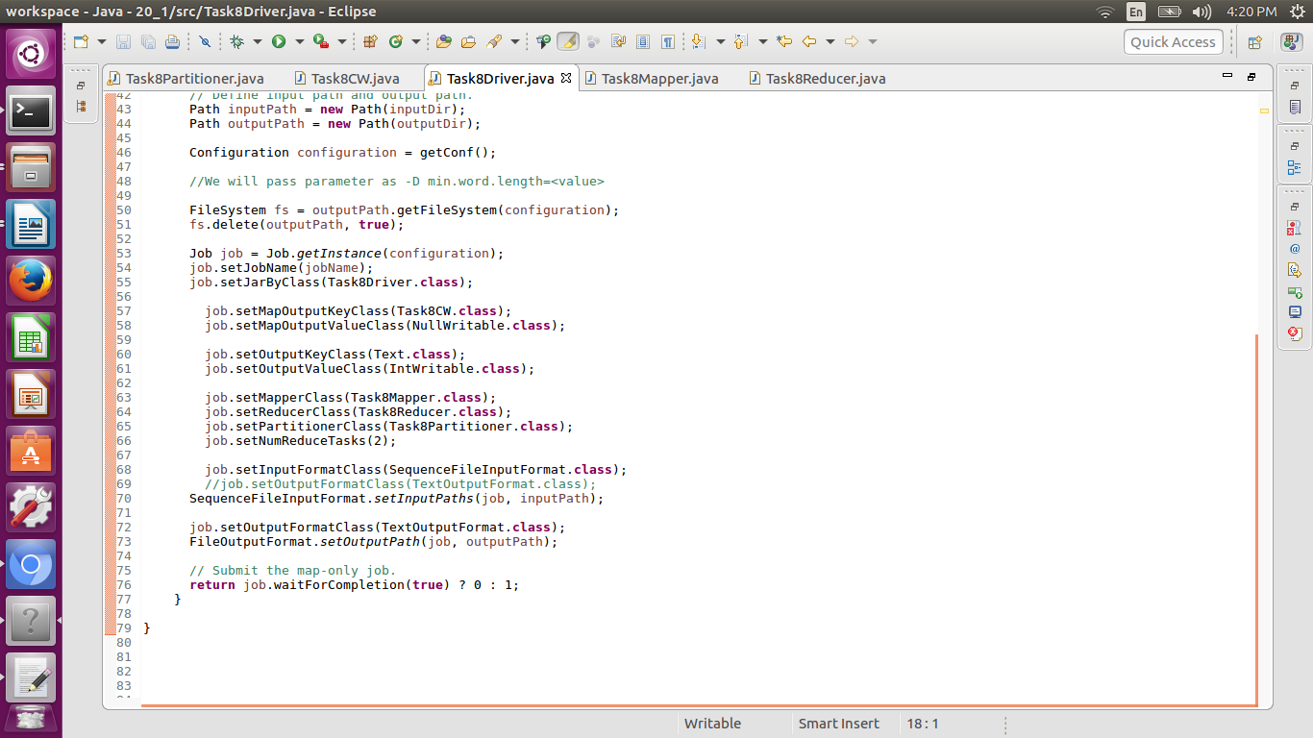

Driver class is used to set classes as well as the jar’s. the driver class is used to set the configurations . it is also used to set number of reducers also to set the partition class.

Custom Writable:

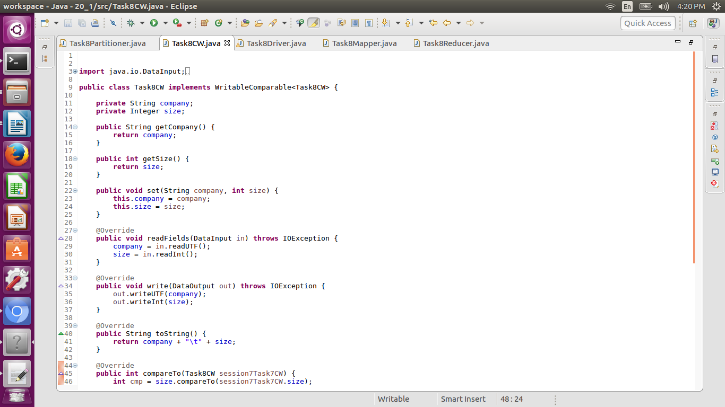

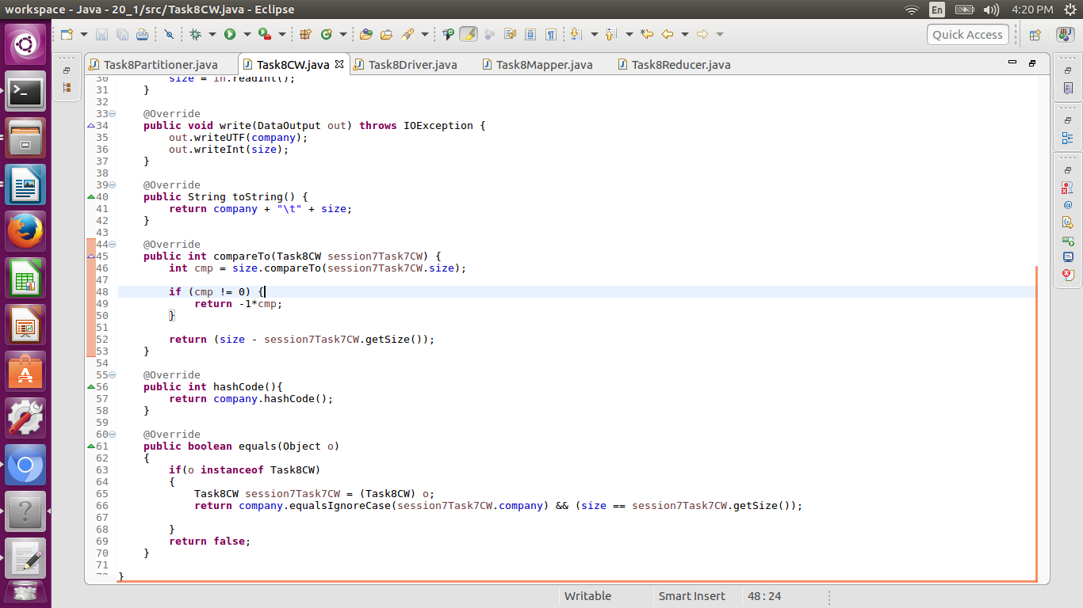

Custom Writable class is used to set the custom key and to compare to sort the key according to need.

Mapper:

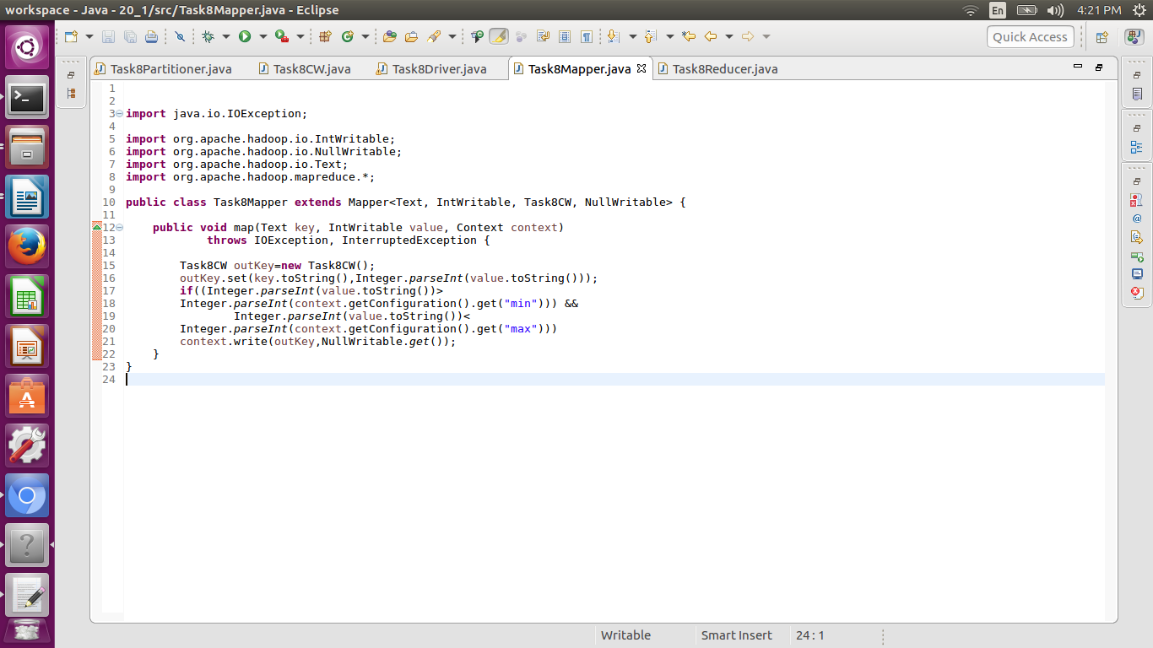

Mapper class is used to map the key value before it is sent to reducer and between the mapper and the reducer shuffle sort is done. The minimum and maximum count is passed through the command line in the variable min and max.

Partitioner:

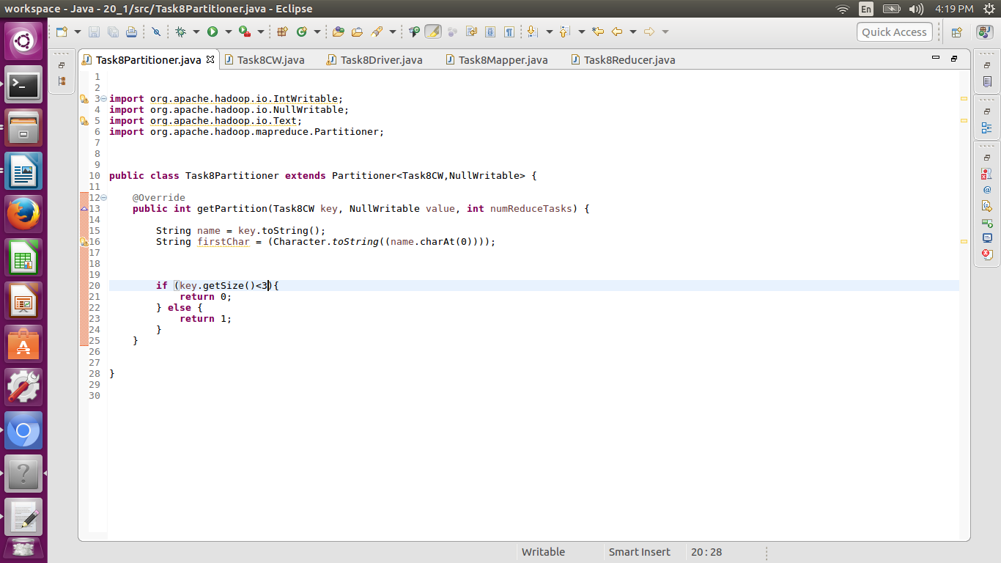

Partitioner class is used to partition the output according to the sold units.

Reducer:

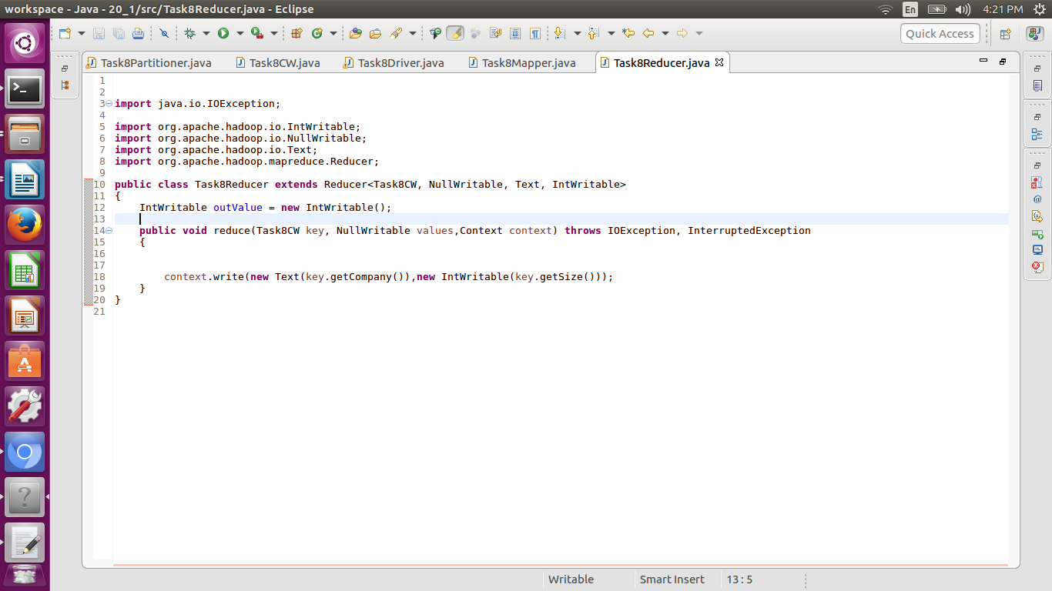

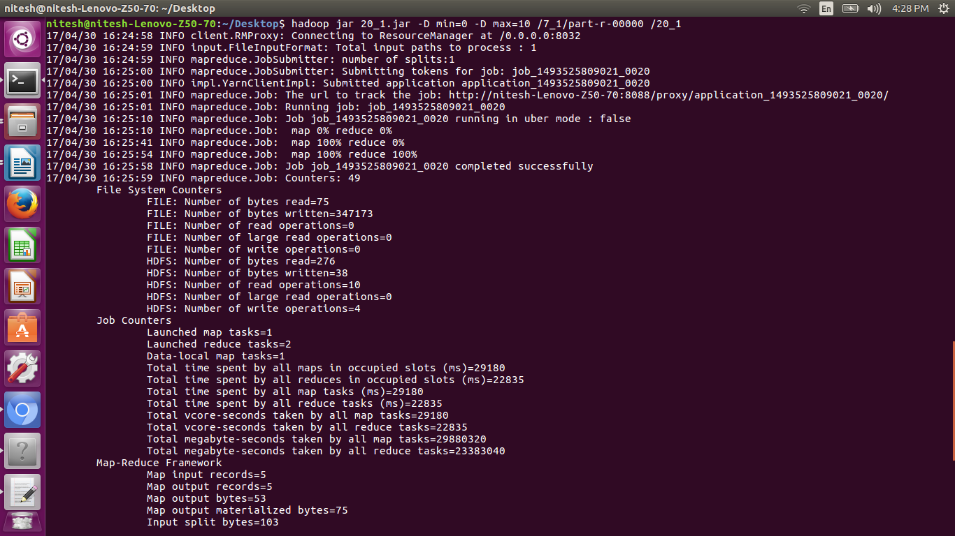

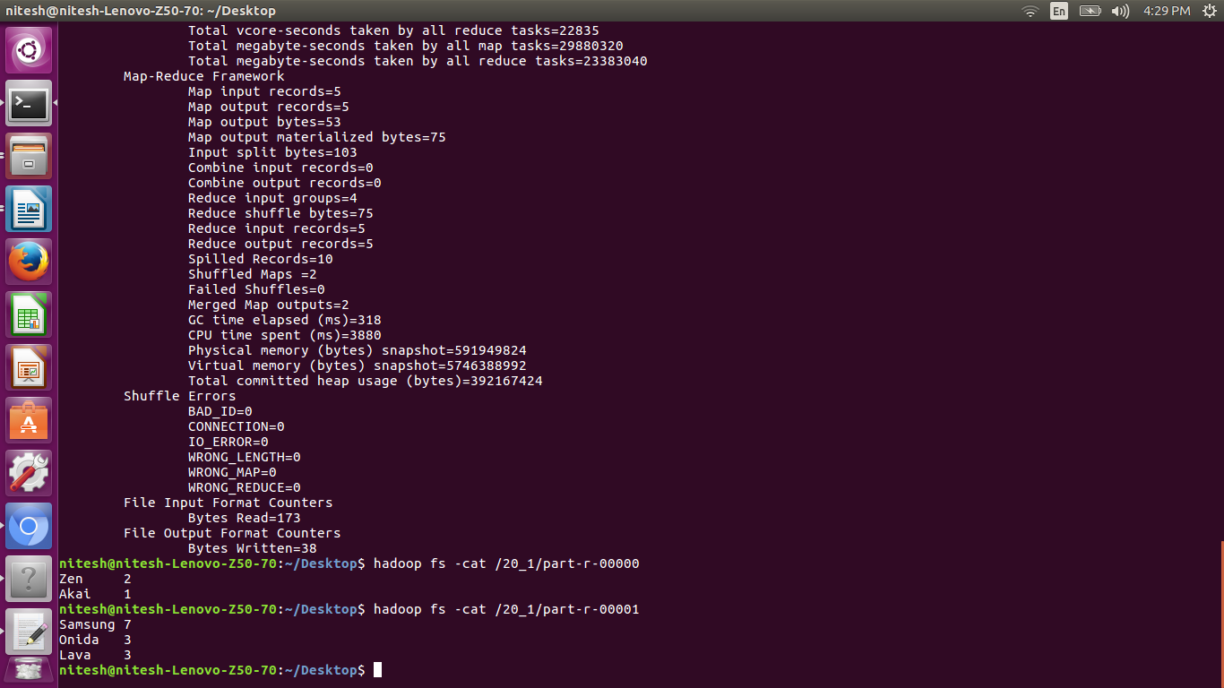

Answer:

The output is partitioned in two parts the sold units below 3 in one partition and 3 and above 3 in next part.